Task |  | Equipment the Participant must be familiar with beforehand. | Time on Task | Maximum Points
Module  1 | Motor Control | PLC Schneider Zelio Logic  PC with programming tools for the PLC Schneider | 270 min | 56
Module 2 | Lighting Control and power outlets | Elko Wireless 4-k switches with battery  Elko Wireless dimmer 250W GLE/I | 210 min | 44
Task total |  |  | 480 min | 100p

Equipment/Tools which the Participant must have with him/her
- Electricians’ hand tools
- Cordless screwdriver with bits
- Crimper for wire ends/ferrules 0,75/1,5/2,5mm²
- Multimeter, resistance and continuity tester
- Work clothes, safety shoes and personal safety equipment including safety glasses and ear protectors
- Safety glasses - to be used at all time during the competition

Task Description
M1 The Participant will mount, connect and start the electrical motor system presented in the appendix. You will create the PLC-controls for the installation with the use of personal computer applications, and use this to program the Schneider PLC which will do the following:
- Starting Conditions:
- Start Switch –S2 will start the motor –M1 in clockwise direction
- Stop Conditions
- Stop Switch –S1 will stop the motor –M1
- Emergency Stop Breaker –S0 will stop the motor –M1
- Overload Breaker –F4 will stop the motor –M1
- Signaling
- Lamp –H1 will display steady light if the Overload Breaker –F4 trips
- Lamp –H1 will blink if the Emergency Stop –S0 is activated
- Lamp –H2 will display steady light when motor –M1 is running
M2 The Participant will mount, connect and start the lighting control system and power outlet as presented in the attached documentation. You will program the Elko Wireless lighting controls for the following scenarios:
- -SWL1
- Right Side, Upper and Lower: dimmer –LL1 Up-Down
- Upper Left - scenario 1: 25 % Light effect -LL1 and 75 % Light effect -LL2
- Lower Left - scenario 2: 75 % Light effect –LL1 and 25 % Light effect -LL2
- -SWL2
- Right Side, Upper and Lower: dimmer –LL2 Up-Down
- Upper Left - scenario 3: 100 % Light effect both -LL1 and –LL2
- Lower Left - scenario 4: Turn off -LL1 and –LL2, Both lights out
Participant’s Name | School | Judge’s Form  Task
 |  | Module 1

Module 1
Motor Control

Preparation Time | 90 min
Break Time
Task Length | 270 min
Total Task Time | 480 min

Subtasks / Point Distribution |  | Maximum Points
A1/A2 | Electrical Safety, Health, Environment and Safety | 10
B1/B2 | Initiation and Function | 22
C | Circuit Design | 6
D1 | Set Up of equipment and wiring | 7,5
E1 | Wiring and Connections | 10,5
Task Total |  | 56
Task Description:
M1 The Participant will mount, connect and start the electrical motor system presented in the appendix. You will create the PLC-controls for the installation with the use of personal computer applications, and use this to program the Schneider PLC which will do the following:
- Start Conditions:
- Start Switch –S2 will start the motor –M1 in clockwise direction
- Stop Conditions
- Stop Switch –S1 will stop the motor –M1
- Emergency Stop Breaker –S0 will stop the motor –M1
- Overload Breaker –F4 will stop the motor –M1
- Signaling
- Lamp –H1 will display a steady light in case the Overload Breaker –F4 trips
- Lamp –H1 will display a blinking light when –S0 is activated
- Lamp –H2 will display steady light when motor –M1 is running

Participant’s Name | School | Judge’s Form Task
 |  | Module 1

 | Description | Judging Criteria | Detra  -cted Points | Max Points | Earned Points
M1 | Motor Control
A1 | Electrical Safety  Modul 1 | 1 Point is detracted for the following faults:  - Correct measurement ofearth continuity resistance – equal to or less than 0,5Ω  - Correct measurement of resistance – equal to or more than 1MΩ  - all covers closed and not damaged before supply connected  3 Points are detracted for one of the following faults  Working on the installation without :  - Disconnecting the power supply  - Securing installation against unintentional reconnection  - Make measurements to insure the power is off |  | 6
A2 | Health, Environment and Safety  Module 1 | 1 Point is detracted for:  - Disorganization of tools, equipment, materials and waste  - Failure to use proper work clothes and shoes  - Failure to use protective glasses and hearing protectors  - Imprecise measurement which leads to unnecessary waste |  | 4
B1 | Starting  Module 1 | 2 Points are detracted for faults with:  - Installation report ok – safe to power up – power up ok – the installation functions as intended  - No second Attempt needed  - No third Attempt needed |  | 6
B2 | Function  Module 1 | 1.5 Points are detracted for faults with:  -S2: -M1 start switch  -S1: –M1 stop switch  -S0: –M1 stops and cannot restart when activated  - Overload –F4: –M1 stops and cannot restart when activated  -H1 steady light indicates Overload –F4  -H1 blinking light signal: indicates –S0 activated  -H2 steady light indicates –M1 running  - Current Direction –M1 clockwise  -F4 adjusted according to motor current  4 Points are detracted for faults with:  - Correct connection of the PLC |  | 16
C1 | Circuit Design  Module 1 | 1 Point is detracted for faults with:  - Color usage on leads to the POS  - Color usage on leads to the M1 and correct connection of the terminal –X1  - Cable type to –S1/-S2/-H2 (RK 5 *0,75)  - Cable type to -POS (3*2,5/2,5)  - Cable type to –M1 (3*1,5/1,5)  - Cable type to –S0 (2*1,5/1,5) |  | 6
D1 | Set up of wiring and equipment  Module 1 | 0.75 points detracted for ≥5mm faults in the placement or orientation:  -CC1  - Box -S1/-S2/-H2  - Box –S0  - Box -POS  -M1  0.75 points detracted for faults in wiring/conduit (Bends, orientation and clamping)  - Flexible Conduit –W1  - Cable –W2  - Cable –W3  - Cable –W5 |  | 7,5
E1 | Cabling and Ends  Module 1 | 0.75 points will be detracted for faults in conductors securely terminated, no damage to leads and no bare copper visible:  -S1/-S2/-H2  -POS  -M1  -S0  -H1/-H2  -F1  -F2  -F3  -Q1  -F4  -PLC  -Clamp boards  0.75 points detracted for faults in neatness:  - Cables in –CC1  - Individual leads in –CC1 |  | 10,5
Sub | Participants total points for M1 Motor Control |  | sum | 56

Participant’s name | School | Judge’s Form Task
 |  | Module 2

Module 2
Install for lighting control and power outlets

Preparation Time | 90 min
Break Time
Task Length | 210 min
Total Task Time | 480 min

Subtasks / Point Distribution |  | Maximum Points
A1-2 | Electrical Safety and Health, Environment and Safety | 10
B1-2 | Initiation and Function | 18
C | Circuit Design | 4
D1 | Set up of equipment and cabling | 7,5
E1 | Wiring and connections | 4,5
Task Total |  | 44

Task Description:
M2 The Participant will mount, connect and start the lighting control system and power outlets as presented in the attached documentation. You will program the Elko Wireless lighting controls for the following scenarios:
- -SWL1
- Right Side, Upper and Lower: dimmer –LL1 Up-Down
- Upper Left - scenario 1: 25 % Light effect -LL1 and 75 % Light effect -LL2
- Lower Left - scenario 2: 75 % Light effect –LL1 and 25 % Light effect -LL2
- -SWL2
- Right Side, Upper and Lower: dimmer –LL2 Up-Down
- Upper Left - scenario 3: 100 % Light effect both -LL1and –LL2
- Lower Left - scenario 4: Turn off -LL1 and –LL2, Both lights out

Participant’s Name | School | Judge’s Form Task
 |  | Module 2

 | Description | Evaluation Criteria | Detra-cted Points | Max Points | Earned Points
M2 | Lighting control and power outlets
A1 | Electrical Safety  Module 2 | 1 Point is detracted for the following faults:  - Correct measurement of earth continuity resistance – equal to or less than 0,5Ω  - Correct measurement of resistance – equal to or more than 1MΩ  - All covers closed and not damaged before supply connected  3 Points are detracted for one of the following faults  Working on the installation without :  - Disconnecting the power supply  - Securing installation against unintentional reconnection  - Make measurements to insure the power is off |  | 6
A2 | Health, Environment and Safety  Module 2 | 1 Point is detracted for:  - Disorganization of tools, equipment, materials and waste  - Failure to use proper work clothes and safety shoes  - Failure to use protective glasses and hearing protectors  - Imprecise measurement which leads to unnecessary waste |  | 4
B1 | Starting  Modul 2 | 2 Points are detracted for faults with:  - Installation report ok – safe to power up – power up ok – the installation functions as intended  - No second Attempt needed  - No third Attempt needed |  | 6
B2 | Function  Module 2 | 1 point detracted for faults with:  -LL1 dimmer up/down with –SWL1 right-hand side  -LL2 dimmer up/down with –SWL2 right-hand side  - Scenario 1  - Scenario 2  - Scenario 3  - Scenario 4  - Function –P1  - Function –P2  4 points are detracted for faults with:  - Correct connection of lighting control system |  | 12
C1 | Circuit Design  Module 2 | 1 point detracted for fault with:  - Color use on leads to –P1/-P2  - Color use on leads to –LL1/-LL2  - Color use on leads to -WLD1/-WLD2 in –JB1  - Cable type to –D1 /-JB1/-LL1/-LL2 (PFXP 3G2,5) |  | 4
D1 | Set up of equipment and wiring  Module 2 | 0.75 points will be detracted for faults of ≥5mm in placement and orientation:  -JB1  -LL1  -LL2  -P1 / -P2  -D1  -D1: in addition to 0,75p for fitting of lid  0.75 points will be detracted for faults in conduit/running cable (bends, orientation and clamping)  - Cable –W4  - Cable –W6  - Cable –W7  - Cable –W8 |  | 7,5
E1 | Wiring and Connections  Module 2 | 0.75 points will be detracted for faults in conductors securely terminated, no damage to leads and no bare copper visible:  -JB1  -LL1  -LL2  -P1  -P2  0.75 points detracted for faults in cleanliness:  - Individual leads in –JB1 |  | 4,5
Sub | Participant’s total points for M2 Lighting Control and Power Outlets |  | Poengsum | 44

Description module 1 & 2
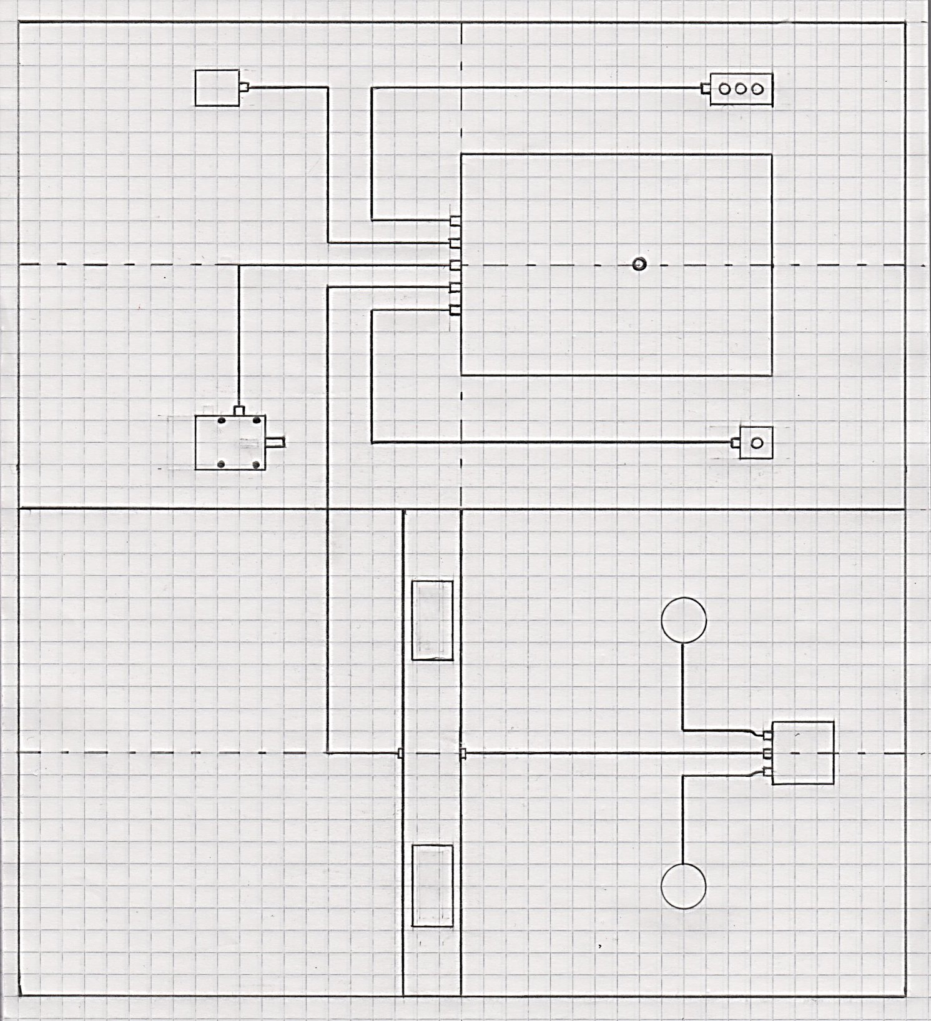
-Centerline
-CC1
-H1
-M1
-POS
-S0
-H2
-S2
-S1
-P2
-P1
-LL1
-LL2
-JB1
-D1
-W5
-W3
-W4
-W2
-W1
-W6
-W8
-W7
GRID SIZE = 50mm

Components Module 1 & Module 2

Component/object | Description/Notes
-S1/-S2/-H2 | Control for motor M1 start and stop - signal lamp indicating –M1 running - green
-S0 | Emergency Breaker for motor –M1
-H1 | Signal lamp for motor control – red
-CC1 | Combined control cabinet for module 1 og 2
-POS | Power connection for 230V 3-phase IT system
-M1 | Three phase AC asynchronous induction motor
-D1 | Duct type Obo Betterman Rapid 80 GK70*130*2000mm
-P1/-P2 | Power outlets type schuko for Rapid 80 GK duct
-SWL1/-SWL2 | Elko WL 4 channel breaker – to be marked and placed in –CC1
-WLD1 | Elko WL dimmer LN for –LL1
-WLD2 | Elko WL dimmer LN for –LL2
-JB1 | Connection box for -WLD1 and -WLD2
-LL1/-LL2 | Rondo SG lighting fixture E27
-W1 | Flexible Conduit Ø 16mm
-W2 | Cable PFSP/N07VCV-U 3*2,5/2,5
-W3 | Cable PFSP/N07VCV-U 3*1,5/1,5
-W4 | Cable PFXP/N05VV-U(R) 3G2,5
-W5 | Cable PFSP/N07VCV-U 2*1,5/1,5
-W6 | Cable PFXP/N05VV-U(R)3G2,5
-W7 | Cable PFXP/N05VV-U(R) 3G2,5
-W8  -F1 | Cable PFXP/N05VV-U(R) 3G2,5  Circuit breaker type RCD 3-phase
-F2 | Circuit breaker type RCD 2-phase
-F3 | Circuit breaker type RCD 2-phase
-Q1 | Contactor for –M1
-F4 | Thermal protection for –M1
-X1 | Terminal block in –CC1
-PLC | Type Schneider Zelio Logic 6/4 I/O 230V

Module 1 & 2
Wiring Diagram One-line form

IT 3*230V

Module 1 & 2
Terminal block –X1

Module 1 & 2
-D1
-CC1
1
Arrangement Drawing for Cabinet –CC1

Module 1 – Main power diagram

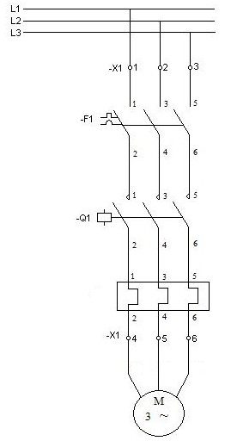
IT 3*230V
I∆
W1
V1
U1
-M1
-F4
Modul 1 – Motor control diagram

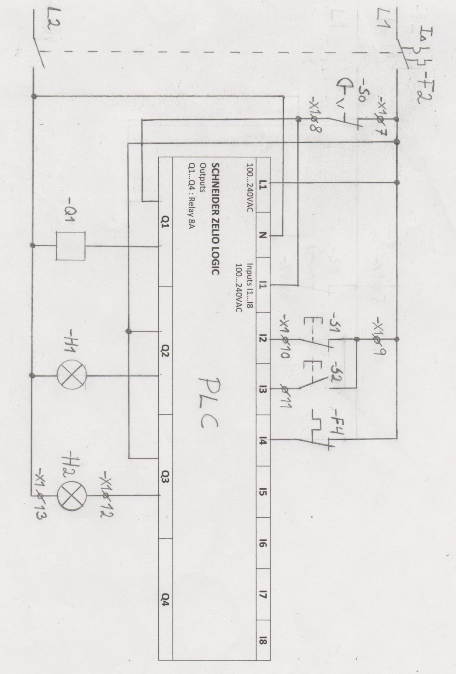

Module 1 – Motor control I/O-list

I/O-LIST
-S0 | I1 | Emergency Stop breaker
-S1 | I2 | Stop Switch
-S2 | I3 | Start Switch
-F4 | I4 | Thermal protection for –M1
-Q1 | Q1 | Contactor for –M1
-H1 | Q2 | Signal lamp  - Steady signal with –F4 activation  - Blinking signal with –S0 activation
-H2 | -Q3 | Signal lamp – signaling –M1 is running

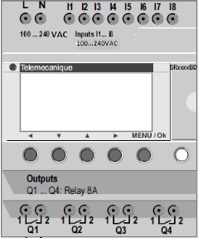

Module 2
Lighting Control and Power Outlets
One-line form Diagram

General information

- RK (H05V2-K) and ferrules will be used for internal connections in the control panel
-F1/-F4: RK 1,5mm²
-F2: RK 0,75mm²
-F3: RK 2,5mm²

- Wago (connectors) for RK will be used to connections in the connection box -JB1
- Free choice of Wago will be used for connection in duct -D1
- TC or TCS (cable clamps) to be used for mounting cables on the wall
- 3-phase assembly bar to supply circuit breakers -F1, -F2, -F3

